**SPH3U: 1.6 Acceleration Near Earth’s Surface**

1. **Acceleration due to gravity**

|  |  |
| --- | --- |
| Acceleration due to gravity: |  |
| free fall |  |

1. **Falling straight down**

A flowerpot is knocked off a window ledge and accelerates uniformly to the ground. If the window ledge is 10.0 m above the ground and there is no air resistance, how long does it take the flowerpot to reach the ground?

What is the final velocity of the flowerpot just before it hits the ground?

1. **Thrown straight up**

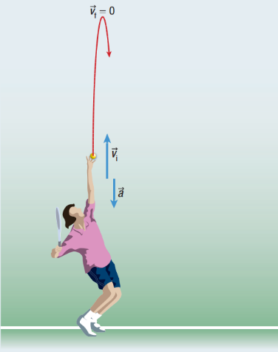

A tennis ball is thrown straight up in the air, leaving the person’s hand with an initial velocity of 3.0 m/s, as shown to the right. How high, from where it was thrown, does the ball go?

How long will it take the ball above to reach its maximum height?

**Homework:** page 43: #3-7